**SYD366-ZRA Presentation: Group 02 members: 1. Dev Patel (142979228) 2. Manav Alpeshbhai Zadafiya (144095221) 3. Patel Arth Bimalbhai (141716225) 4. Mohamed Ashraf Bharot (139539225) Date: 17 April 2024 Professor: Chris Alexander**

**User Story:**

Realizing the need for a more systematic approach to gather feedback, Linda decides to implement a product survey form within her retail software solution. Linda sets out to design and implement a user-friendly survey form integrated into her retail software. The survey form allows customers to provide detailed feedback on individual products, sharing their experiences and suggestions with ease.

**Why do we feel user story is important?**

The survey form is very important factor in the business to know customer as it provides valuable insights from customer’s point of view. Implementing a survey form is important for Linda's retail business for several reasons such as:

**1. Understanding Customer Preferences:** A survey form allows Linda to gather direct feedback from her customers regarding their preferences, likes, and dislikes about specific products. By understanding customer preferences, Linda can tailor her inventory to meet customer demands effectively, leading to higher customer satisfaction and increased sales.

**2. Improving Product Offerings:** Feedback collected through surveys provides valuable insights into which products are popular and which ones may need improvement or replacement. Linda can use this information to refine her product offerings, introduce new items, or discontinue products that are not well-received, thereby optimizing her inventory.

**3. Enhancing Customer Engagement:** Inviting customers to participate in surveys demonstrates that Linda values their opinions and seeks to create a personalized shopping experience. This engagement fosters a stronger connection between Linda's business and her customers, leading to increased loyalty and repeat visits.

**4. Identifying Areas for Improvement:** Surveys help Linda identify areas of her business that may require improvement, such as customer service, product quality, pricing, or overall shopping experience. Addressing these areas based on customer feedback can lead to operational enhancements and ultimately higher customer satisfaction.

|  |  |  |  |
| --- | --- | --- | --- |
| Use Case Name | Add Product survey | | |
| Triggering Event |  | | |
| Brief Description | User wants to add product survey | | |
| Actors | User | | |
| Preconditions | User has already main menu | | |
| Post Conditions | Survey form has been submitted successfully and can be queried | | |
| Flow of activities | User | | System |
|  | 1. | Requests to add product Survey | Displays list of sales and orders of products and prompts to select a product (productID) |
|  | 2. | Selects Product | Receives productiD and displays the list of products of that type and prompts for product survey (productid, saleID) |
|  |  | Loop starts | Chooses a new product for survey form |
|  | 3. | Enters productid, saleID , suggestion , rating | Receives productid, saleId, ratings, suggestion and creates a survey id |
|  | 4 | User confirms the entered data | Displays the survey form with submitted information |
|  |  | Loop ends | User has submitted all the product survey forms |
|  | 5 | Chooses to exit and save | Saves the data. return to the main menu |
| Assumption | * User chooses valid product to do survey | | |
| Exception Conditions | * User chooses to abort the process | | |

|  |  |  |  |
| --- | --- | --- | --- |
| Use Case Name | Query product survey | | |
| Triggering Event |  | | |
| Brief Description | Owner wants to query product survey form | | |
| Actors | Owner | | |
| Preconditions | Owner has already opened the main menu | | |
| Post Conditions | Order is successfully placed and can be queried | | |
| Flow of activities | Owner | | System |
|  | 1. | Requests products survey forms | Displays the survey form of each product and prompts for selection |
|  | 2. | Enters the product (productid, surveyID) | Validate productid and surveyID and retrives the list of survey form for that product |
|  | 3 | Chooses to cancel | Returns to main menu |
| Assumption |  | | |
| Exception Conditions | * Owner chooses to abort the process | | |

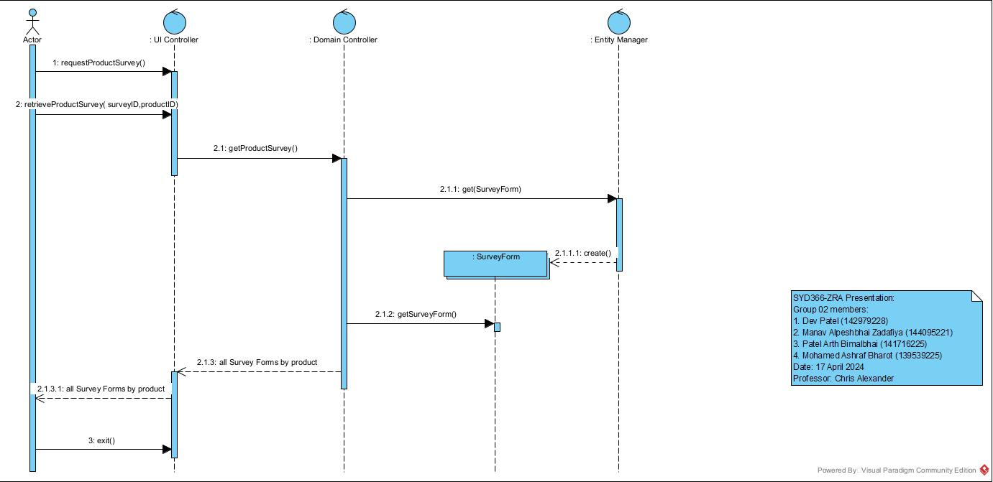

Controller

